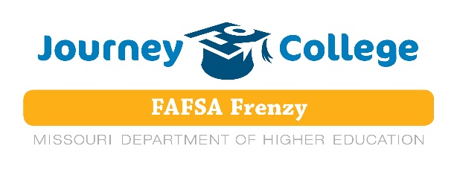

Calling all Students making plans to go on to post-secondary training…
… 2 or 4 year college/university or Technical Training …

Battle High School (BHS), Columbia Area Career Center (CACC) and Hickman High School (HHS) in Columbia, Missouri are hosting a "FAFSA Frenzy" with the MDHE (MO Department of Higher Ed) for ANY student wanting assistance completing the FAFSA (Free Application for Federal Student Aid).
The FAFSA is the primary application used by federal, state, and institutional financial assistance entities in determining an individual's eligibility for grants, loans, work-study, and scholarships.
- Many post-secondary institutions look at a March 1 deadline, for scholarships.
- A short presentation and then a CONFIDENTIAL place to complete the FAFSA paperwork with an expert will be available at all locations.
- NEW: Starting with Academic Year 2017-18, the traditional submission date of January 1 has CHANGED to OCTOBER 1. This will be a permanent change to the date.
- In addition, families will be able to use tax information from the prior year (2015).
  - The January 1 start date made it difficult for families to get their tax information gathered in time to complete the application. By moving it earlier to October 1, students will have more time to fill out this vital information, they’ll have tax info at hand, and families will have more time to evaluate the post-secondary school’s financial aid award package.
______________________________________________________________________________
THREE LOCATIONS AND THREE DATES to choose from:

Columbia Area Career Center (CACC) Hickman High School
4203 S. Providence Road, Columbia, MO 65203 1104 North Providence Road, Columbia, MO 65203
Date: Sunday, October 15, 2017 Date: Tuesday, October 10, 2017
Time: 2:00 p.m. – 4:00 p.m. Time: 5:00 p.m. – 7:00 p.m. Location: CACC, Start Room 173B Location: HHS Media Center Parking in the West side of the building HHS: 214-3000
CACC: 214-3800

Battle High School
Date: Wednesday, October 11, 2017
Time: 5:00 p.m. – 7:00 p.m.
Location: BHS
For more information call BHS: 214-3300

